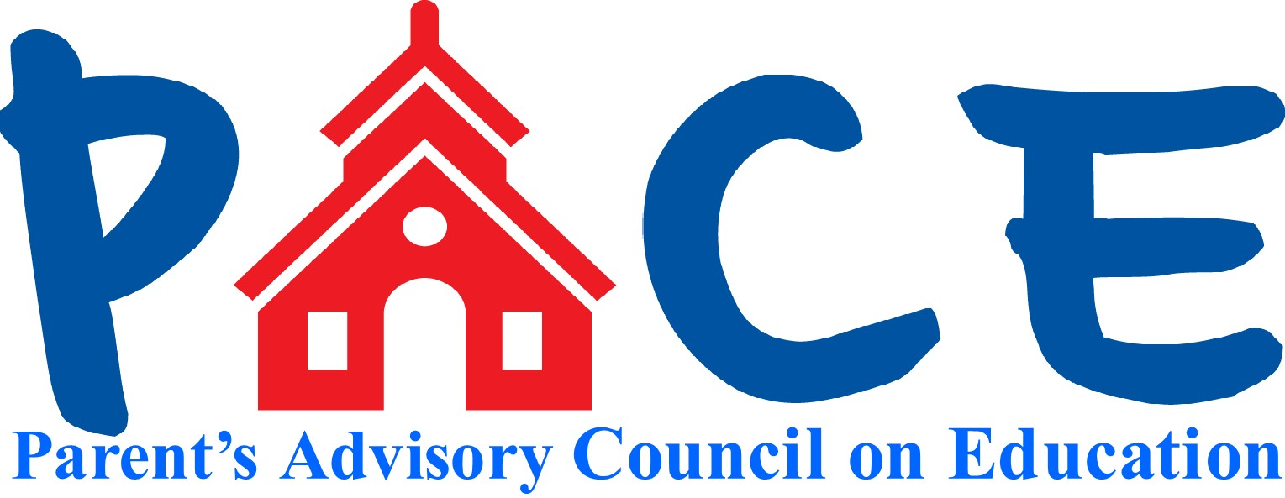

Calendar 2016-2017

August

* Enroll Spelling Bee
* Back to School Folders
* Kindergarten Orientation

September

* First PACE Meeting
* 5K Fun Run and Trail Run (cancelled for this year, check next year to see if have it)
* Back to School Night – sell directory, cookbook, HOPE stickers
* Picture Days

October

* Fall Book Fair
* Halloween Dance
* Talent Show Auditions

November

* Talent Show
* Kids Go Shopping
* Spirit Wear

December

* BINGO
* Holiday Donations for Hopedale families in need

January

* School Play

February

* Classroom spelling bees – need dates
* BINGO for books – need dates

March

* Science Fair
* Random Acts of Kindness week
* Grade & School Spelling Bee
* Square One Art order form to go home
* Family Fitness Night
* Healthy Snack Week
* Unplug Challenge

April

* SEPAC Fundraiser
* School Vacation
* Research and confirm enrichment programs for next year
* Spring Book Fair

May

* Teacher Appreciation Week (check MCAS conflicts)
* Boosterthon RRICK Run Fundraising starts

June

* Boosterthon RRICK Run
* Barnes and Noble Fundraiser
* Drive-In Movie Night